Union assignments

Mandatory
- Refer the code below and comment on size of the given structure considering
  - Structure as union
  - Structure as struct
  - arr
  - uarr

___ Job
{
char name[32];
unsigned short ucount;
float salary;
int workerNo;
char *orgname;
};

___ Job myvar; //could of union or of struct
Struct Job arr[10];
Union Job uarr[10];
- char→32 bytes
unsigned short→2 bytes
float →4 bytes
int →4 bytes
char *→4 bytes
Total :46 bytes
a. structure as union: 32 bytes
b. structure as struct :46 bytes
c. arr : 10*46 bytes=460
d. uarr: 10*32 bytes=320

- Refer Job datastructure in Q#1 above. Using uarr, perform below operations.
  - Read and store salary
  - Read and store workerNo
Comment on values of output if salary and workerNo are printed in order. Justify your statement.
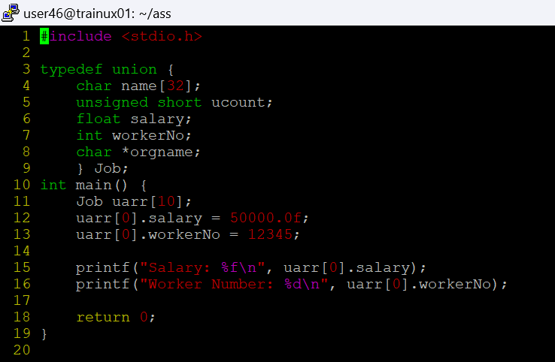
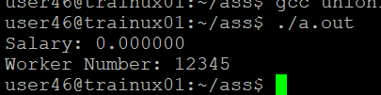
In unions only 32 bytes are created for the structure. When workerNo is given the salary is overridden so we do not get the salary output

- Refer Job datastructure in Q#1 above. Assume that myvar is a structure variable. If I need to place 2 bytes (i.e 0x0102) as ucount using a char *ptr then list all possible statements that can be used in _____.
[Let solutions include cases such as
    - using base address of ucount
    - using relative address of ucount w.r.t to base address of myvar]
int main()
{
char *ptr = &myvar;

___________ = 0x01;
___________ = 0x02

}

- *ptr =0x01;
*(ptr+1)= 0x02
ii) As ucount is at 32 we directly access that bit
*(ptr+32)=0x01;
*(ptr+33)=0x02;

